**Robot Body:**

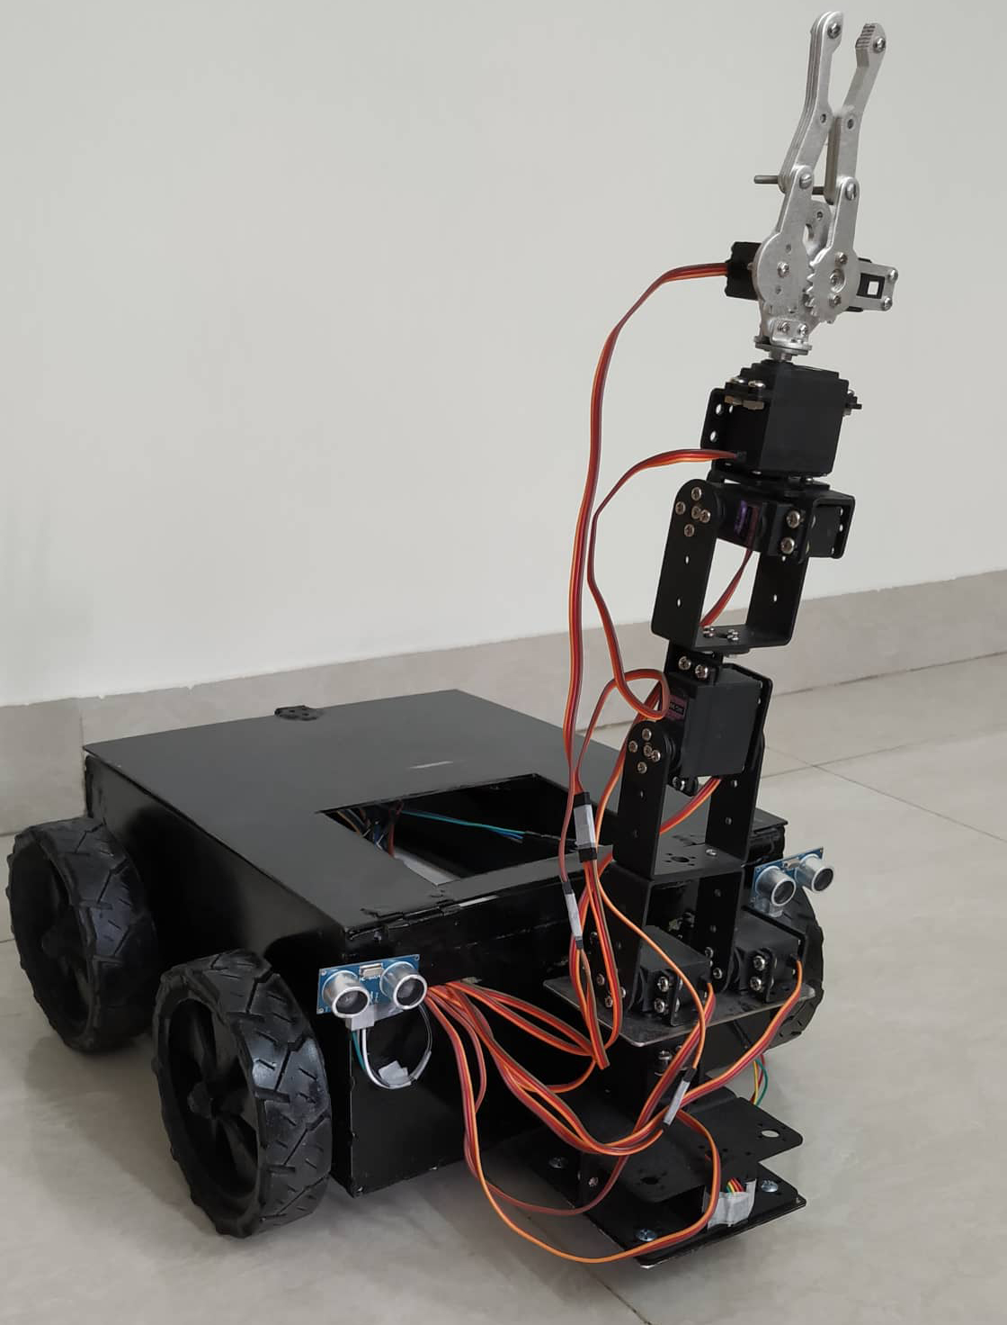

Length: 30 cm

Width: 26 cm

Height: 13 cm

Wheel Diameter: 11cm

Car body 2 cm above ground

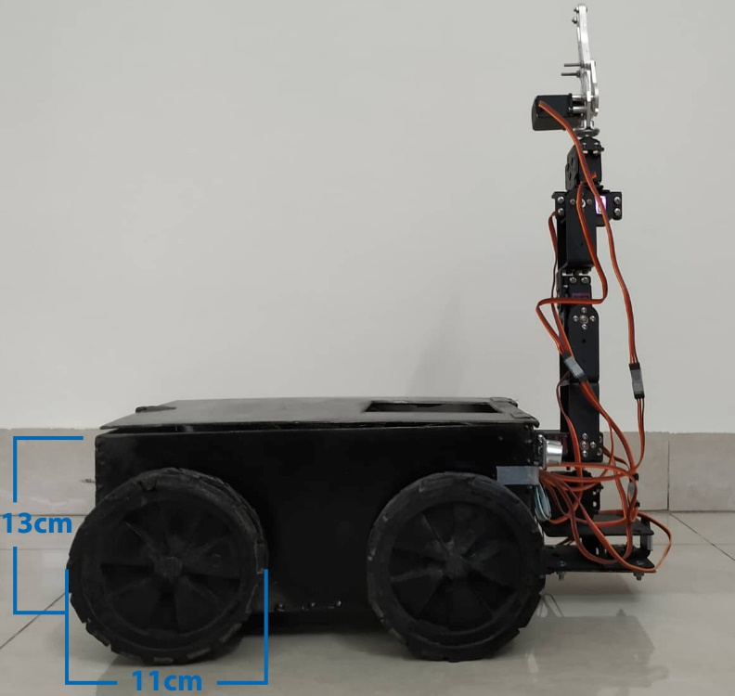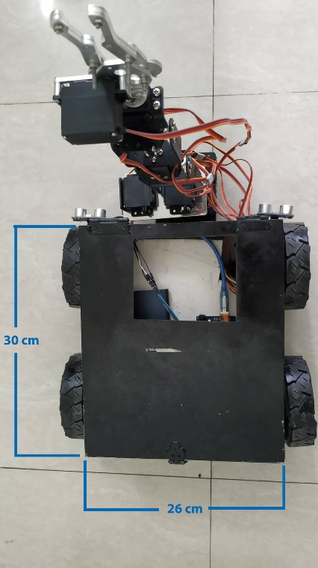

**Fig: Height of the Robot Car & Wheel Diameter Fig: Length & Width of Robot Car**

**Motor:**

**Toyota Denso Window Motor[1][2]**

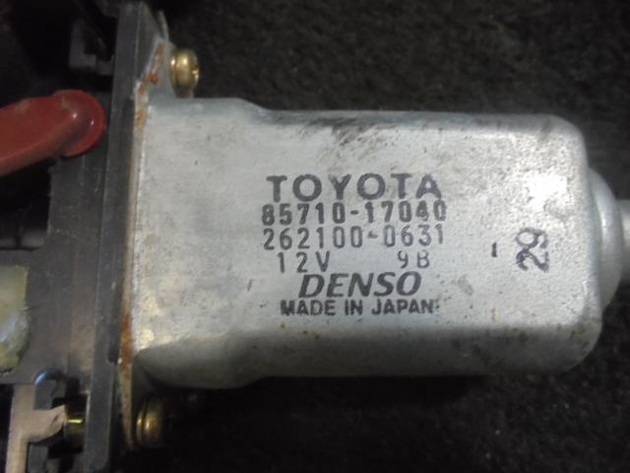

RPM : 80±10rpm (no load)

55±15rpm (with load)

Max Voltage: 12v

No Load Current: < 2A

Stall Current: < 8A

Rated Torque: 3 N.m ~ 30.6 kg-cm

Stall Torque: 9.8N.m ~ 100kg-cm

**Calculation:**



While robot is moving forward:

Using right hand rule,

Direction of F is to the left creating 0-degree angle with the width for Right-sided motors.

Direction of F is to the left creating 180-degree angle with the width for Left-sided motors.

So, in both cases, length of width is canceled out as sin(0)=0.

But, Direction of F is to the left creating 90-degree angle with the length for Right-sided motors.

Direction of F is to the left creating 90-degree angle with the width for Left-sided motors.

So, for both cases, torque value should me maximum as sin(90)=1.

1 Denso motor gives torque of 100 kg-cm.

Length of the robot: 30cm

So, Maximum weight 1 motor can lift: 100/30 kg =3.3 kg

Maximum weight 4 motor can lift: 3.3kg x 4 = 13.33 kg

Same mechanism for moving backward, right and left.

Note: We have tested with 15kg weight above the robot and it worked absolutely fine. So, we can say the motors are much more powerful than it was scripted by the company.

**Power Consumption:**

One motor consumes approximately 2~2.5A depending on its movement. For instance, while moving forward and backward it consumes 2A. On the other hand, while moving right and left it consumes 2.5A. It is because of the drifting of both motor at the opposite directions. While moving right, left sided motors rotate clockwise and right sided motors rotate counter clockwise. To cancel out this opposite direction drifting each motors consumes higher current than moving forward or backward.

So, In total 4 motors consumes: (2~2.5 x 4) A = 8 ~ 10 A

We are using 12v 7.5Ah battery. So, the uptime of our robot is: 7.5/10 hr = 0.75 hr = 45 mins

It means, Our robot can be driven up to 45mins straight with full load and working capacity.

As our battery takes 2A initial current for charging it will take (7.5/2) hr = 3.75 hr = 3hr 45 mins to fully charged.

Reference:

1. <https://www.alibaba.com/product-detail/high-torque-power-window-motor-denso_60417655175.html>

2. <https://www.cytron.io/p-power-window-motor-wira-left>